
SRM Institute of Science and Technology
Mode of Exam
OFFLINE
SET B

College of Engineering and Technology
DEPARTMENT OF ECE
SRM Nagar, Kattankulathur – 603203, Chengalpattu District, Tamilnadu
Academic Year: 2021-2022 (EVEN)
Batch 2
Test: CLAT-3 Date: 27/06/22
Course Code & Title: 18ECC202J / Linear Integrated Circuits Duration: 2 Periods
Year & Sem: II year / IV Sem Max. Marks: 50
Course Articulation Matrix:
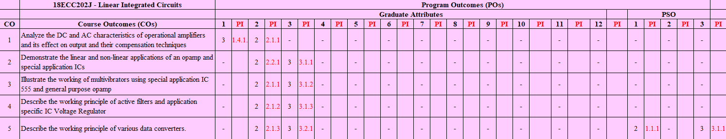

Part - A
(10 x 1 = 10 Marks)
Instructions: Answer ALL
Q. No | Question | Marks | BL | CO | PO | PI
1 | The change in output voltage for the corresponding change in load current in a 7805 IC regulator is defined as  - Current boasting  - Line regulation  - Load regulation  - Input regulation | 1 | 1 | 4 | 2 | 2.1.2
2 | The 7812 regulator IC provides ________.  A. 5 V  B. -5 V  C. 12 V  D. -12 V | 1 | 1 | 4 | 2 | 2.1.2
3 | The frequency when the gain drops by 3 dB is  A. Band frequency  B. Cut off frequency  C. High frequency  D. Low frequency | 1 | 1 | 4 | 2 | 2.1.2
4 | The lower and upper cut off frequency of a band pass filter is 2.5KHz and 10 KHz. Determine the bandwidth  - 750 Hz  - 7500Hz  - 700Hz  - 70Hz | 1 | 2 | 4 | 2 | 2.1.2
5 | How can a first order low pass filter can be converted into second order low pass filter?  A. By adding LC network  B. By adding RC network  C. By adding RC || LC network  D. By adding RLC network | 1 | 1 | 4 | 2 | 2.1.2
6 | The number of comparators used in 5 bit flash ADC is ………..  A. 31  B. 32  C. 4  D. 5 | 1 | 1 | 5 | 2 | 2.1.3
7 | A dual slope ADC uses 16-bit counter with analog voltage of 4.12V and V_{R}=6V. Its binary equivalent is …….  - 1010111111001001  - 1011111111001001  - 1010111101001001  - 1010100111001001 | 1 | 2 | 5 | 3 | 3.2.1
8 | Flash type ADC requires _____ resistors for 4 bit conversion  - 3  - 15  - 4  - 16 | 1 | 1 | 5 | 2 | 2.1.3
9 | ……….. is the maximum deviation between actual and ideal converter output after gain and offset errors have been removed.  - Absolute accuracy  - Relative accuracy  - Relative /absolute accuracy  - Linearity | 1 | 1 | 5 | 2 | 2.1.3
10 | Calculate the value of the full scale output for an 8-bit DAC for the 0 to 10 V range.  A. 9 V  B. 6.961 V  C. 10 V  D. 9.961 V | 1 | 2 | 5 | 3 | 3.2.1
Part – B
( 4 x 10 = 40 Marks)

SECTION B1
Instructions: Answer ANY 2 Questions
11 | Derive the transfer function of a second order filter whose frequency response is shown below and find the expression for Damping coefficient.  INCLUDEPICTURE "http://www.evalidate.in/lab3/images/LowPassFilter-I/LowPassFilter_T2.jpg" \* MERGEFORMATINET 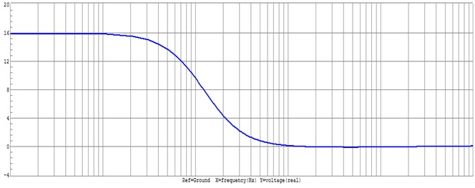 | 10 | 3 | 4 | 3 | 3.2.1
12 | Draw the cicuit diagram of Twin -T Notch filter.Obtain the expression for bandwidth and quality factor . | 10 | 3 | 4 | 2 | 2.1.2
13 | Explain how the current limit and current fold back are achieved in IC723 voltage regulator | 10 | 2 | 4 | 2 | 2.1.2

SECTION B2
Instructions: Answer ANY 2 Questions
14 | - Explain the working of Flash type ADC.  - What are its merits and demerits? | 6+4 | 3 | 5 | 2 | 2.1.3
15 | - Describe the operation of successive approximation type ADC.  - What are the advantages of dual slope ADC? | 6+4 | 2 | 5 | 2 | 2.1.3
16a | A dual slope ADC uses a 16-bit counter and a 4 MHz clock rate. The maximum input voltage is +10 V. The maximum integrator output voltage should be - 8 V when the counter has cycled through 2n counts. The capacitor used in the integrator is 0.1 µF. Find the value of the resistor R of the integrator. | 6 | 4 | 5 | 3 | 3.1.2
16 b. | In the above problem, if the analog signal Va is +4.129 V.Find the  equivalent digital number. | 4 | 4 | 5 | 3 | 3.1.2

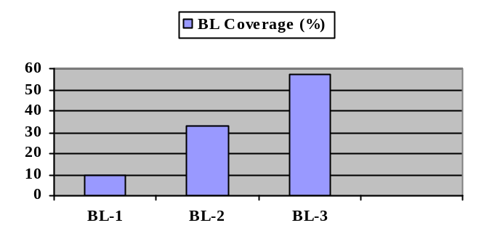Course Outcome (CO) and Bloom’s level (BL) Coverage in Questions
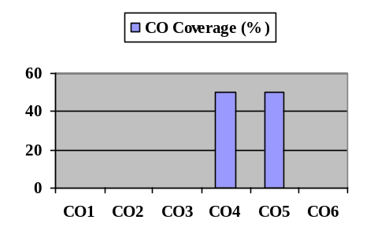

Approved by the Course Coordinator Signature of the Question paper setter

Evaluation Sheet
Name of the Student: Register No.:

Part- A (10 x 1= 10 Marks)
Q. No | CO | PO | Maximum Marks | Marks Obtained | Total
1 | CO4 | 2 | 1
2 | CO4 | 2 | 1
3 | CO4 | 2 | 1
4 | CO4 | 2 | 1
5 | CO4 | 2 | 1
6 | CO5 | 2 | 1
7 | CO5 | 3 | 1
8 | CO5 | 2 | 1
9 | CO5 | 2 | 1
10 | CO5 | 3 | 1
Part- B (4 x 10= 40 Marks)
11 | CO4 | 3 | 10
12 | CO4 | 2 | 10
13 | CO4 | 2 | 10
14 | CO5 | 2 | 6+4
15 | CO5 | 2 | 6+4
16a | CO5 | 3 | 6
16b | CO5 | 3 | 4

Consolidated Marks:

CO | Maximum Marks | Marks Obtained
4
5
Total

PO | Maximum Marks | Marks Obtained
2
3
Total

Signature of Course Teacher

